**PRADEEP S**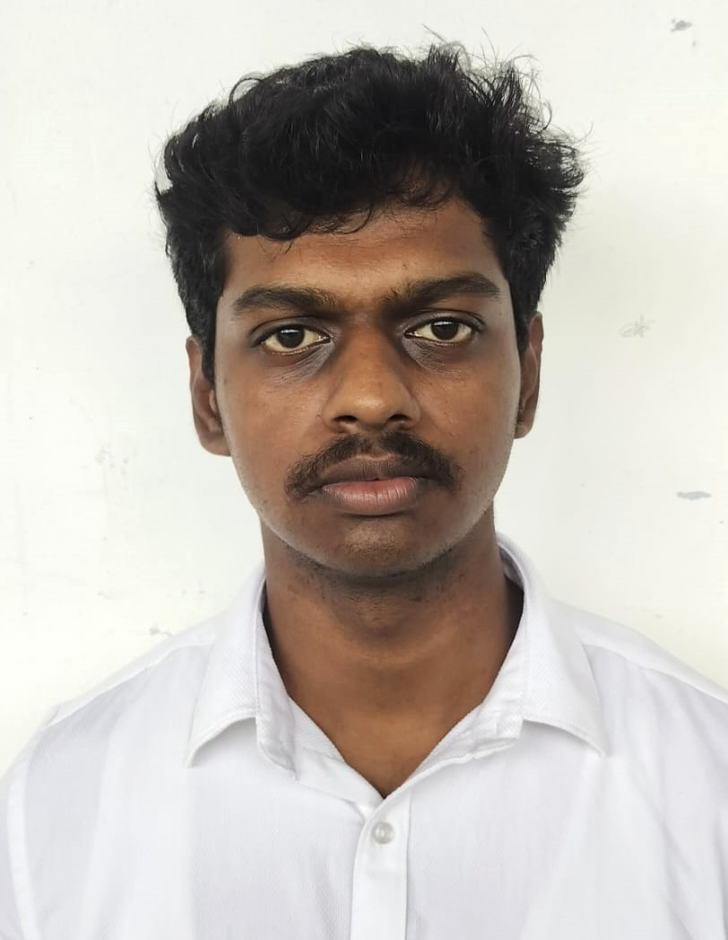

**EMAIL :** [pradeepsrinivasan3569@gmail.com](mailto:pradeepsrinivasan3569@gmail.com)

**LINKED IN**  **:** <https://in.linkedin.com/in/pradeep-s-865484255>

**CONTACT :** 6381620289

**GitHub** **:**https://github.com/prady-42

**CAREER OBJECTIVE :**

Seeking a challenging position with a reputable organization where I can acquire new skills, broaden my knowledge and use what I’ve learned.

**ACADEMIC BACKGROUND :**

|  |  |  |  |
| --- | --- | --- | --- |
| **QUALIFICATION** | **NAME OF INSTITUTON** | **YEAR OF PASSING** | **CGPA / PERCENTAGE** |
| B.E Computer Science and Design | Karpagam Academy of Higher Education | 2026 | 7.28* |
| HSC | KRP Matriculation Higher Secondary School | 2022 | 63.16 |
| SSLC | KRP Matriculation Higher Secondary School | 2020 | 82.6 |

**PROJECT DETAILS :**

* **TITLE :** EXPENSE TRACKER APPLICATION
* **ABSTRACT :** Developed a robust and user-friendly expense tracker application designed to help users manage and monitor their financial transactions effectively. Key features include transaction categorization, expense analytics, budget management, and real-time data visualization
* **LANGUAGE USED :** Python , HTML ,CSS, JS, NodeJS, SQL

**TECHNICAL SKILLS :**

* Programming Language : C(intermediate), Python(intermediate), Java(basic)
* Web design / Database : HTML, CSS, MySQL, JS, PHP

**INTERNSHIP :**

* Undergone at Internship at Pantech e-Learning as a **Python Full-Stack Developer** for the period of **30** days.
* Undergone at Internship at Prime Solution as a **Front-end Developer** for the period of **15** days.

**CERTIFICATES :**

* Certification in Cloud & Networking by Simplileran.
* AWS Certification in AWS Academy Cloud Foundation.
* Course Completed Salesforce AI with Agentforce Foundation.
* Introduction To CyberSecurity By CISCO.

**ACADEMIC ACHIEVEMENT :**

* NCC B&C Certificate.
* National level EBSB / NCC Certificate-2024 at Rajasthan.
* International level Seminar Conference – Conducted By ABRSM.

**AREA OF INTEREST :**

* Web Development
* Full Stack Developer
* Front-end and Back-end Developer
* App Developer

**PERSONAL SKILLS :**

* Critical Thinking and Problem Solving
* Adaptability
* Leadership Quality

**DECLARATION :**

I hereby declare that all the information furnished above is true to the best of my consent.

**DATE :**

**PLACE :** COIMBATORE PRADEEP S